Ingredients
- 1 kg Chicken
(cut in medium sized pieces)
- 2 Cups Fenugreek Leaves
(coarsely chopped)
- 175 g Yogurt (whisked)
- 1 canchoppedTomatoes
- 2 Onions
(finely chopped)
- 1 tbsp Garlic Paste
- ¾ tbsp Ginger Paste
- 3-4 Green Chillies
(chopped and seed removed for less heat)
- 1 tsp Cumin Seeds
- 1 ½ tsp Red Chilli Powder
- 1 ½ tsp Coriander Powder
- 1 tsp Cumin powder
- ½ tsp Turmeric powder
- 1 tsp Garam masala powder
- 2 tsp Lemon juice
- 1 tsp Sugar
- ⅓ cup Cream
- 5 tbsp Oil
- Salt as per taste
- Water as required
- 4 green cardamom
- 8-10 black pepper corns
- 4-5 cloves

MethiChicken

Methi Chicken Curry or MethiMurghi is a delicately spiced, creamy and delicious curry of chicken cooked with fenugreek leaves.

- First heat oil in a pan. We used a mix of olive and mustard oil.
- While the oil gets heated, add cumin seeds, and allow it to crackle. Once the aroma of fried cumin releases, add chopped green chili, cardamom, pepper corns and cloves.
- Then, add chopped onions and saute on high heat for a minute. Fry until they just pick the golden colour. At the same time, be sure to not to over brown the onions.
- Add chicken, tomatoes, ginger garlic paste, saute them well on high heat for 2-3 minutes.
- Once the chickens sautéed well, reduce the heat and add whisked yoghurt. Immediatelystirwell till the yoghurt combines well.
- Then, add red chilli powder, turmeric powder, coriander powder, cumin powder, salt and water. Cover and simmer for 6-7 minutes or until the chicken is tender
- Add fenugreek leaves (methi) and lemon juice and cook on high for another minute or 2.
- Finally, add cream, garam masala powder and sugar. Mix everything together and cook for another 2-3 minutes.

Ingredients
- 2 medium Eggplants (washed)
- 1 medium Tomato (washed)
- Green chillies(according to taste)
- 1 Medium Onion(chopped)
- 1/4 cup Coriander leaves (chopped)
- 3 tbsp Mustard Oil
- 1 tbsp lemon juice
- Salt

Spicy Aubergine Puree

Begun Pora (Bengali Baingan Bharta) is an utterly delicious Bengali recipe made with roasted eggplant and mustard oil. Begun pora is very simple and quick to prepare and makes a healthy and wholesome meal when served with roti or rice.

- First, score the eggplants with a knife and rub it with some mustard oil and salt. Do the same with tomato without scoring. Now put the vegatables in an oven or air fryer at 200 degrees.
- Roast this for 20 to 25 minutes or until cooked through and soft. Prick it with a knife or fork to check the doneness.
- The skin will be partially charred but it adds a lovely smoky flavors to the dish. Take it off the heat and let it cool slightly.
- Blend the roasted eggplants and roasted tomato,.
- Fry onion until golden and put the eggplant mixture, green chilies, lemon juice and coriander.Fry until there is no excess water.

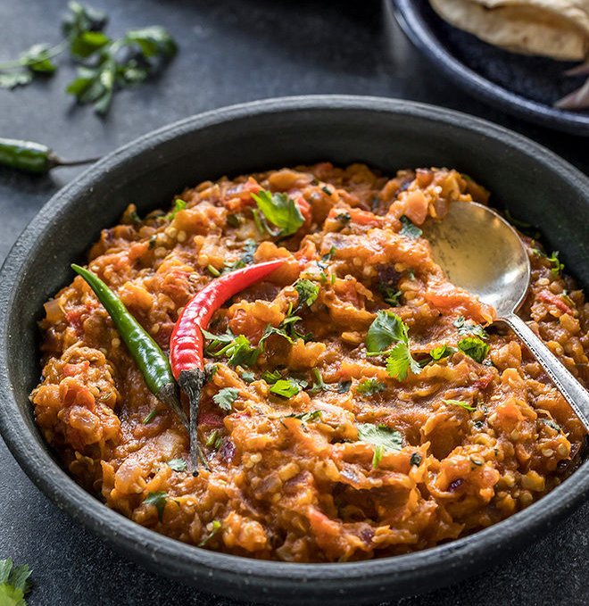

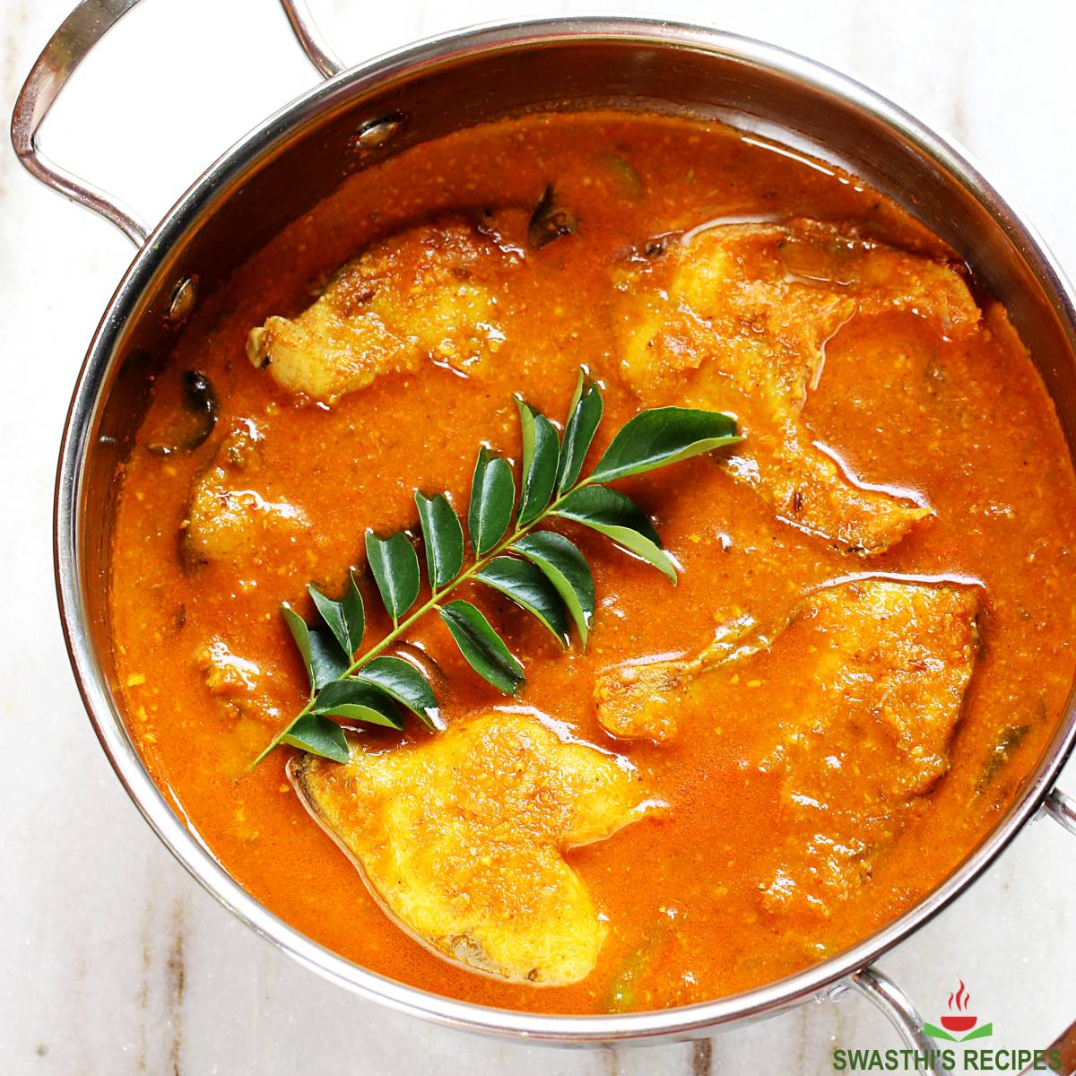

Ingredients
- 1kg Pangas fish
- 4 tbsp olive oil
- 2 tbsp mustard oil
- 2 medium onions
- ½ tsp turmeric powder
- ½ tsp cumin powder
- ½ tsp coriander powder
- 1 can choppedtomatoes
- Coriander leaves
- 2 green chilies

Fish Curry

Begun Pora (Bengali Baingan Bharta) is an utterly delicious Bengali recipe made with roasted eggplant and mustard oil. Begun pora is very simple and quick to prepare and makes a healthy and wholesome meal when served with roti or rice.

- Fry the onions in oil until golden.
- Add some water, turmeric, cumin, coriander.
- Wait until the water evaporates, add fish and saute for 5 minutes.
- Add tomatoes, lemon juice and one cup of water.
- Cook on low medium heat for 30 minutes. Shake the pan from time to time to stir.
- Add chilies and coriander leaf one minute before the end of the 30 minutes.

Ingredients
- 2 cups Red Lentils
- 4 medium Onions
- Green Chilies(According to taste)
- Salt (According to taste)
- 1 tsp Turmeric Powder
- ½ tsp Paprika Powder
- 2 tsp Gram Flour(Chickpea flour)
- 1 to 2 tbsp Oil
- 2 tsp garlic paste
- ½ cup Coriander Leaves
- Salt

Lentil Onion Fritter
Piyaju or Lentil fritters are famous Bangladeshi snack. This is a crispy bite sized snack and is loved by the whole nation.

- Soak lentil for 3 hours in water. You may soak them overnight as well. After lentils are soaked in water for enough time, drain.
- Next, in a blender, make a paste out of the lentils. Try not to use any water for this process. It can be time consuming but following this process will give you thick paste which is ideal for good fritters.
- Once blending is done, put the lentil paste in a bowl. Add salt, turmeric powder, paprika powder, garlic paste, gram flour and mix. I prefer mixing it with hand to ensure a great mixture.
- Then add sliced onions, green chilies and coriander Leaves and mix well. Finally pour a table spoon of oil and mix one final time.
- Make flat, round balls and fry them until done.

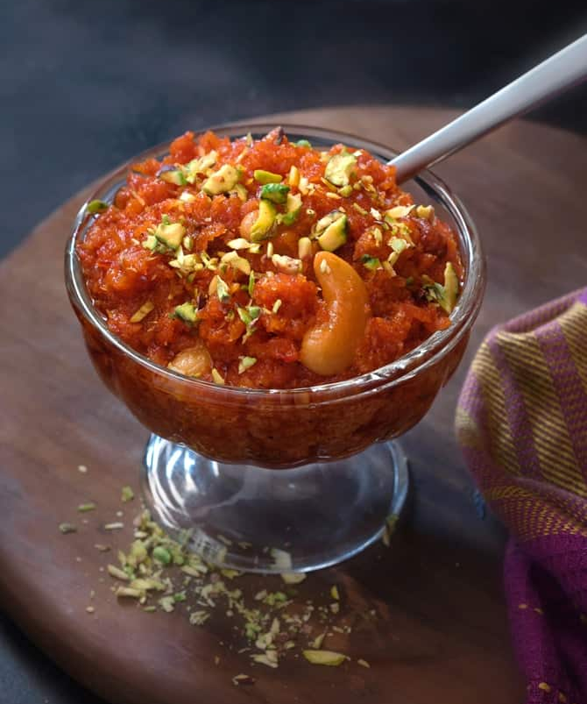

Ingredients
- 1 kg Carrot (grated)
- 120 g Ghee(can be replaced with butter)
- 350 ml Full Fat Milk
- 150 g Condensed milk
- ¼ cup Raisins
- ¼ cup Cashew Nuts
- A very generous big pinch of saffron soaked in 1 tablespoon of milk (optional)
- ▢2 tsp Cardamom Powder
- 1 cup Sugar (you may increase/decrease as preferred)
- Slivered pistachios or almond or mixed dry fruits for garnish

Carrot halwa

Carrot halwa - is traditional sweet recipe of grated red carrots slow cooked in ghee, milk, condensed milk and sugar.

- Clean, wash, peel and grate the carrots.
- In a heavy bottom pan, heat ghee.
- Add grated carrot, increase the heat and saute well on high for 6-7 minutes stirring well.
- Let it cook in ghee on a medium heat for another 5 minutes.
- Add milk, mix and simmer on low until milk reduces and is absorbed well.
- Add condensed milk, raisins and cashews, mix until condensed milk combines well.
- Add saffron milk, cardamom powder, sugar and mix well till it dissolves completely.
- Increase the heat and saute for another 5 minutes stirring continuously.
- Dish out, garnish and serve.

